|  |  |
| --- | --- |
|  | AUSTRALIAN HIGH COMMISSION  DHAKA |

**9 February 2014**

**NGOs Receive Grants under Australia’s Direct Aid Program 2013-14**

Australian High Commissioner Greg Wilcock today presented approximately BDT 1.5 crore (AUD 220,000) to eight NGOs for community development in Bangladesh.

The grants were made under the Australian High Commission’s Direct Aid Program (DAP) 2013-14. The eight NGOs received the payments during a gathering at the High Commissioner’s residence.

The projects receiving DAP assistance this year include: women’s empowerment through skill development in Natore; rehabilitation support for Rana Plaza victims; establishment of safe water supply and fish farming in the Chittagong Hill Tracts; good governance at the community level through Muslim leaders; and support for acid violence victims.

The NGOs participating in this year’s DAP round are: The Asia Foundation, Acid Survivors Foundation (ASF), Shishu Polli Plus (SPP), JAAGO Foundation, Bangladesh Legal Aid and Services Trust (BLAST), ALWO, Kumudini Welfare Trust and The Glencoe Foundation.

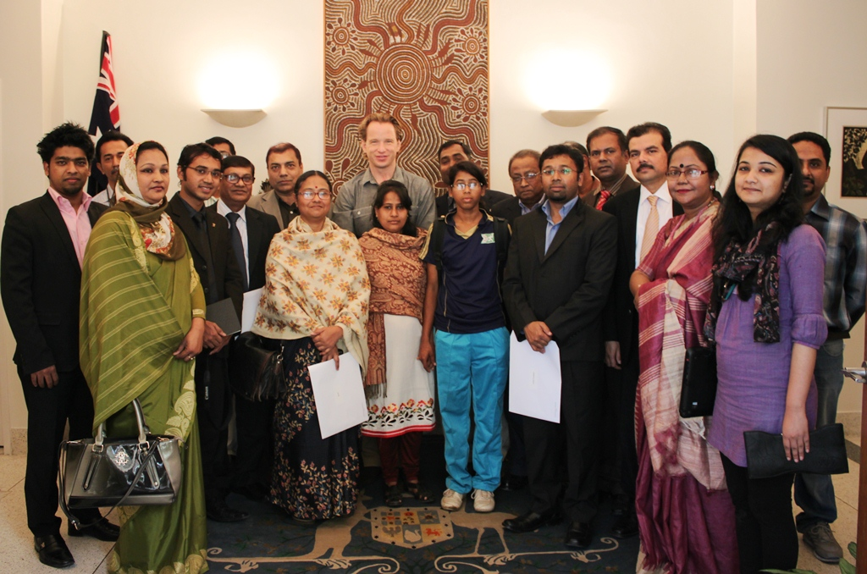

*Australian High Commissioner Mr Greg Wilcock (centre) with DAP 2013-14 grant recipients*

DAP supports humanitarian need, local development, human rights and good governance. Individuals, communities, NGOs, academic institutions, research bodies, libraries, museums, and others engaged in development can apply for grants.

More information on DAP can be found on the Australian High Commission’s website at: <http://www.bangladesh.embassy.gov.au/daca/development_cooperat.html>

For further information please contact:

Senior Research and Communications Officer, AHC Dhaka

Tel: 8813105 (497)

E-mail: ahc.dhaka@dfat.gov.au